Steps to setup HDP search:

1. Download the Ambari management pack to the Ambari Server host.

**cd /tmp**

**wget** <http://public-repo-1.hortonworks.com/HDP-SOLR/hdp-solr-ambari-mp/solr-service-mpack-5.5.2.2.5.tar.gz>

1. Install the management pack on the Ambari Server host, using the following command:

**ambari-server install-mpack --mpack=/tmp/solr-service-mpack-5.5.2.2.5.tar.gz**

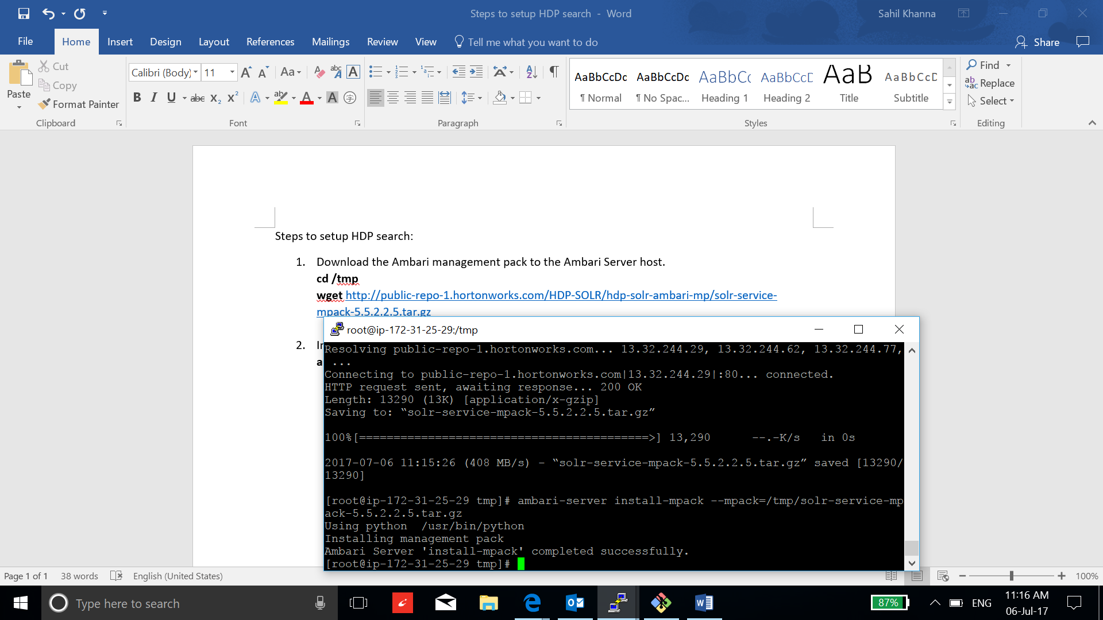

1. Edit the file: /var/lib/ambari-server/resources/stacks/HDP/2.6/repos/repoinfo.xml, add the HDP-SOLR-2.5-100: <http://public-repo-1.hortonworks.com/HDP-SOLR-2.5-100/repos/centos6>

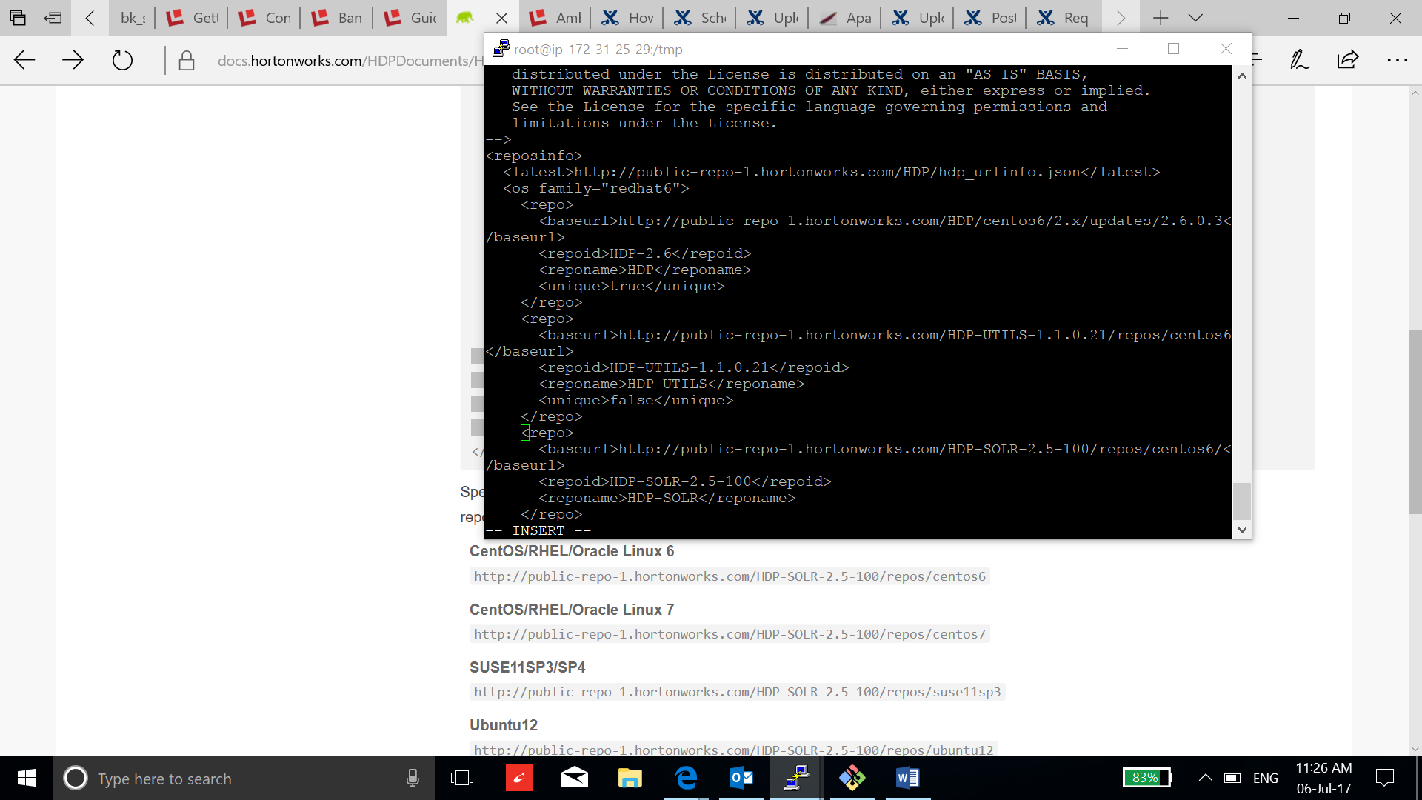

1. Restart the Ambari Server, to recognize the new repository and the management pack:

**ambari-server restart**

1. Now go to the Ambari and select add service to add solr:

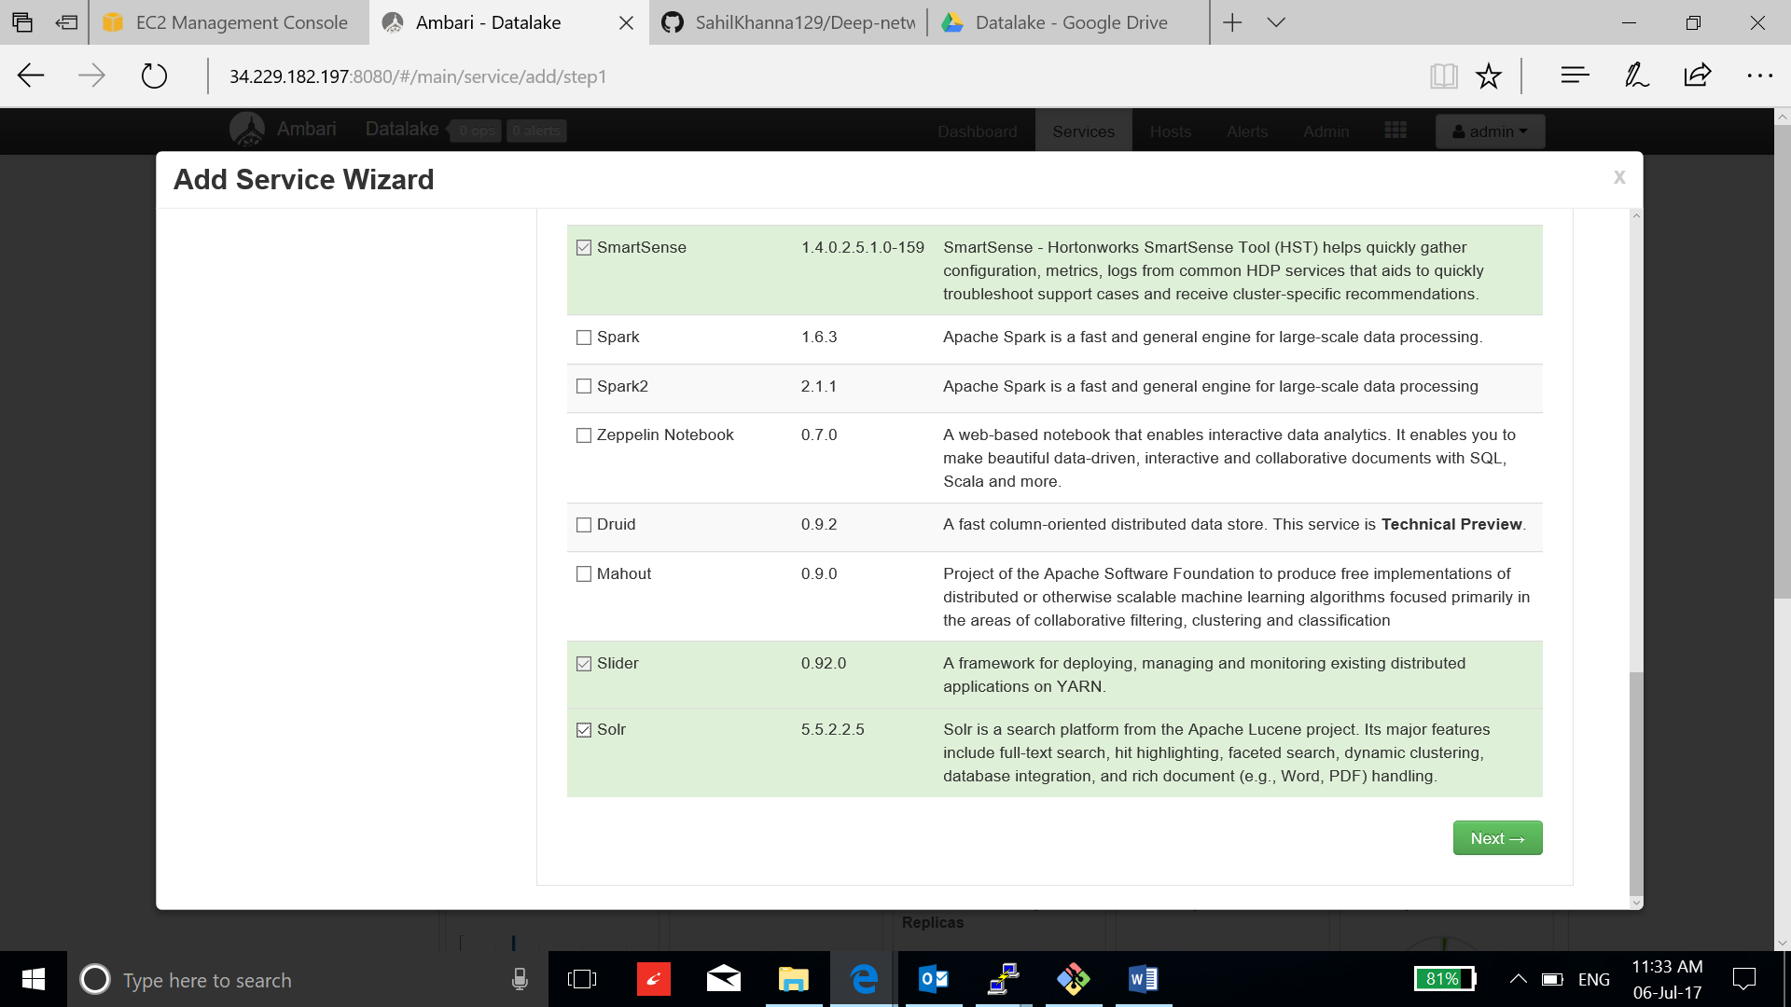

1. Appoint Solr master to the instance and click next:

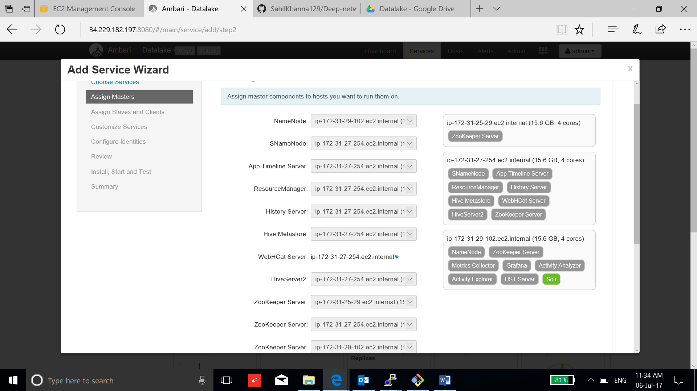

1. Keep the default configuration and click next:

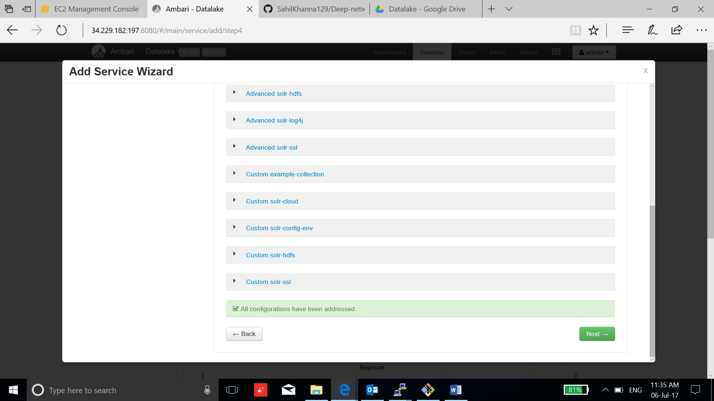

1. Review and click deploy:

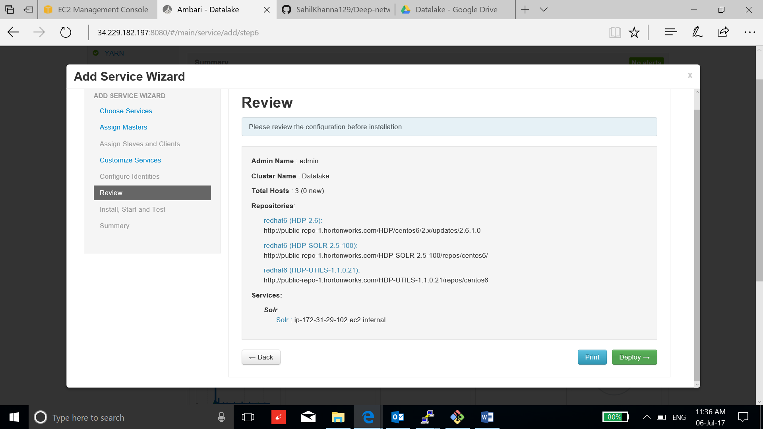

1. After the installation is complete, click next and complete the process:

